Data Type

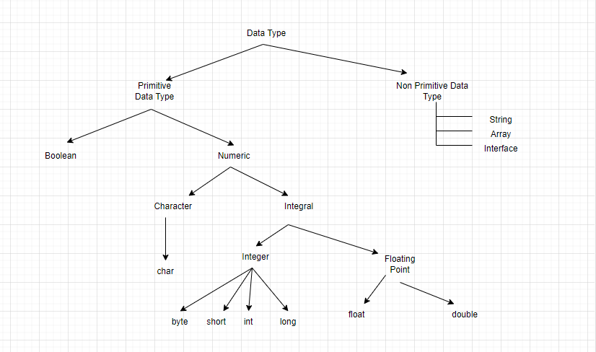

|  |  |  |
| --- | --- | --- |
| **Data Type** | **Default Value** | **Default Size** |
| boolean | FALSE | 1 bit |
| char | \u0000' | 2 byte |
| byte | 0 | 1 byte |
| short | 0 | 2 byte |
| int | 0 | 4 byte |
| long | 0L | 8 byte |
| float | 0.0f | 4 byte |
| double | 0.0d | 8 byte |